Development Architecture

Overall Development Architecture of all versions of ICode

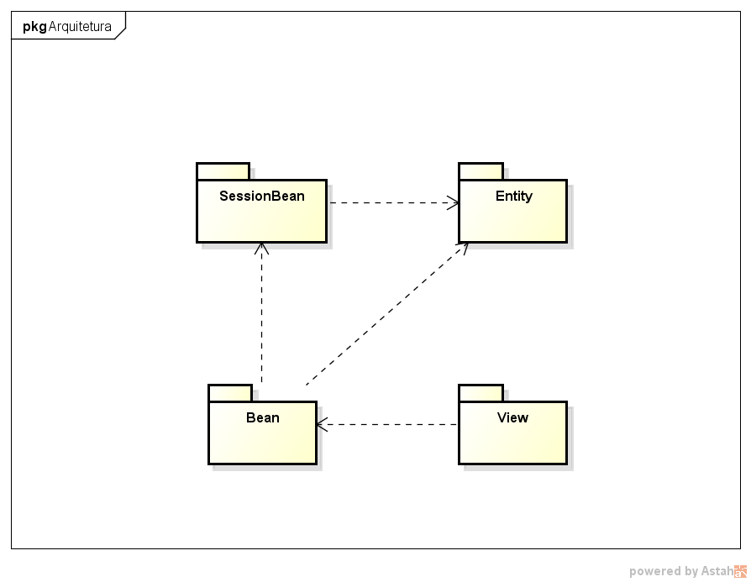

Technological Information:

Programming language used is Java-WEB (JSF), along with xhtml, css and javascript for view rendering.

Uses Hibernate for entity-relational management.

Uses Primefaces for view rendering and management.